**Lab report 04**



**CSE 402L**

**Digital Signal Processing Fall 2024**

**Submitted by: Naveed Ahmad**

**Registration No.: 22PWCSE2165**

**Class Section: B**

**Semester :5th**

*“On my honor , as student of University of Engineering and Technology, I have neither given nor received unauthorized assistance on this academic work”*

Student Signature: ____________

Submitted to:

**Dr. Yasir Saleem Afridi**

Nov. 18, 2024

Department of Computer Systems Engineering

University of Engineering and Technology Peshawar

Section 01:

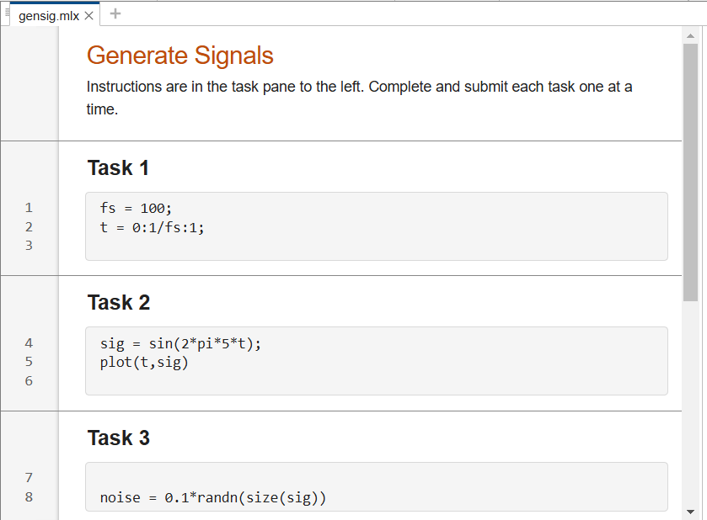

In this section I learnt how Defined the sampling frequency and created a time vector, Generated a 5 Hz sinusoidal signal using a mathematical formula, and Introduced random Gaussian noise to the generated sinusoidal signal.

Section 02:

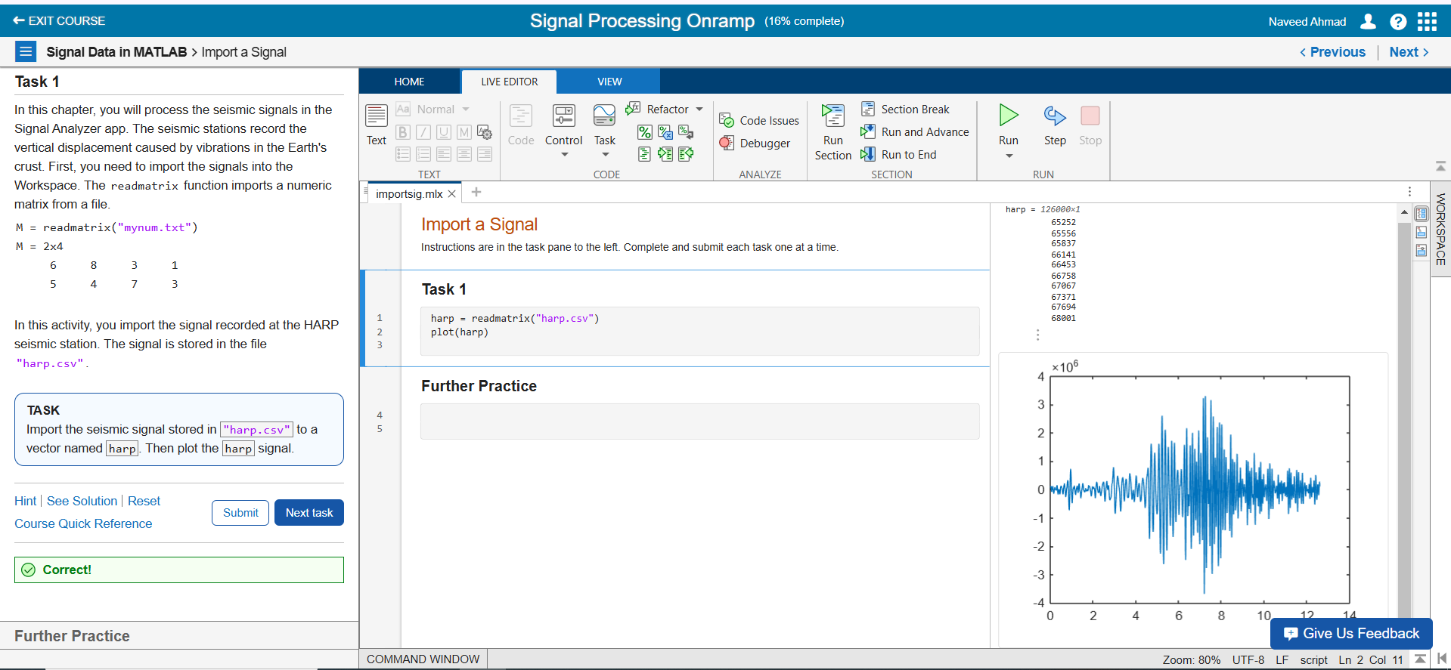

I learned how to import seismic data using readmatrix, store it in a variable, and plot the signal for analysis.

Section 03:

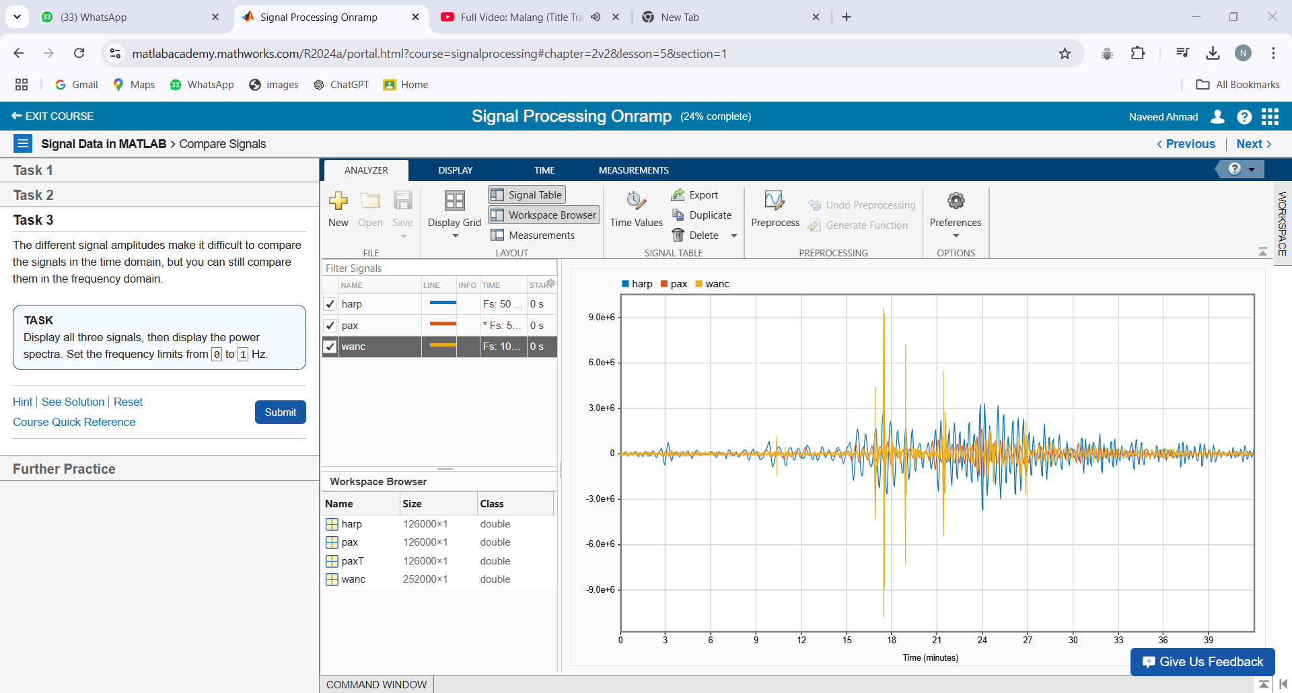In this section, I learned to display multiple signals, compare their amplitudes, and analyze them in the frequency domain.

Section 04:

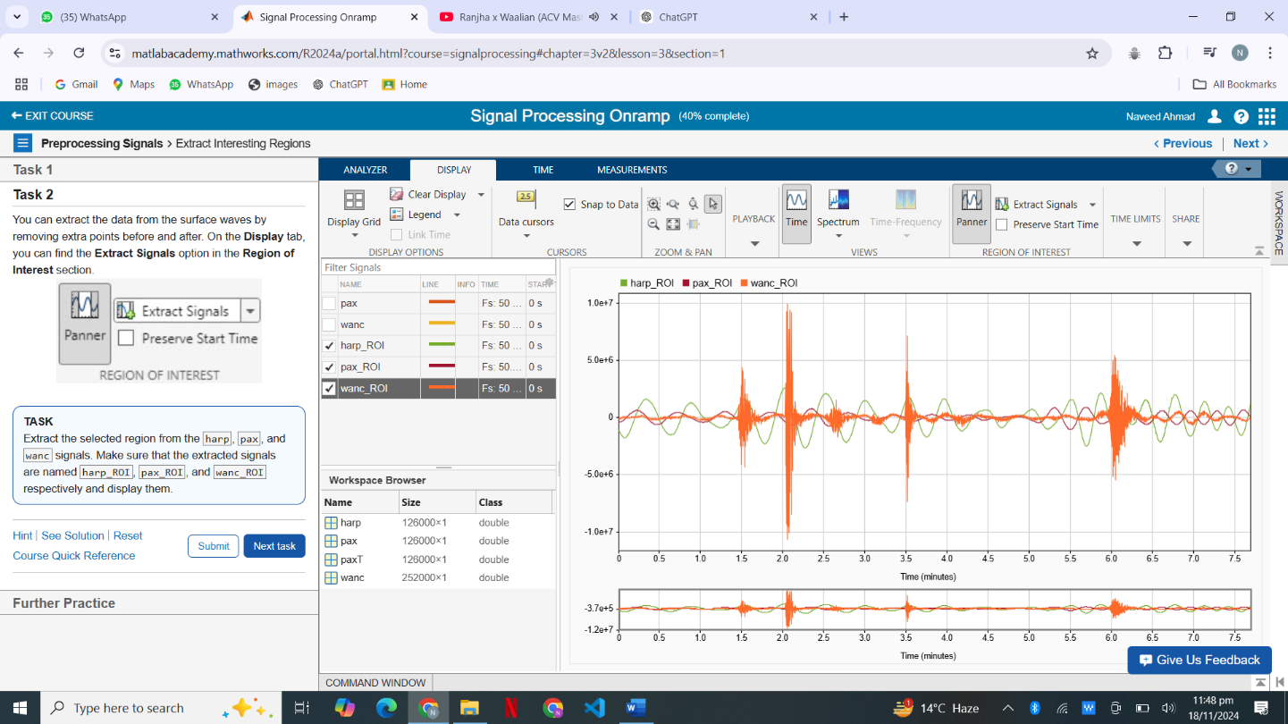

In this section I learnt how to extract signals from the region of interest, and functionality of panner tool in MATLAB.

